

**Faculty of engineering - Shoubra**

**Benha University**

Report of Programming Languages Project

Name: Tarek Mohamed Mohamed Elsayed Hassan

B.N: 431

Topic: Programming Languages

Application Brief:

It is not something surprising that programmers have risen to create something new in this age. With the creating of internet, we know there would be something new. Because of programmers, we could even use computer apps without the internet access. In this age, it is really a great help for the novice to be knowing something new in their life even without the access of internet which is always payable. Without programming, we would always be carrying with us our computer whatever it is wherever we go because internet access is a total need.

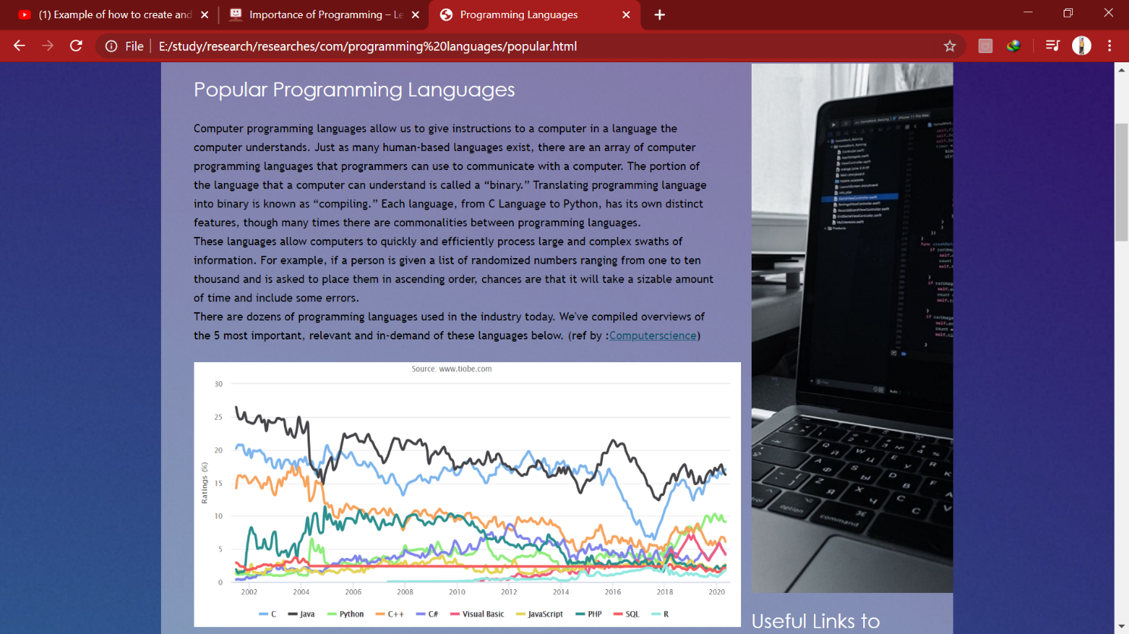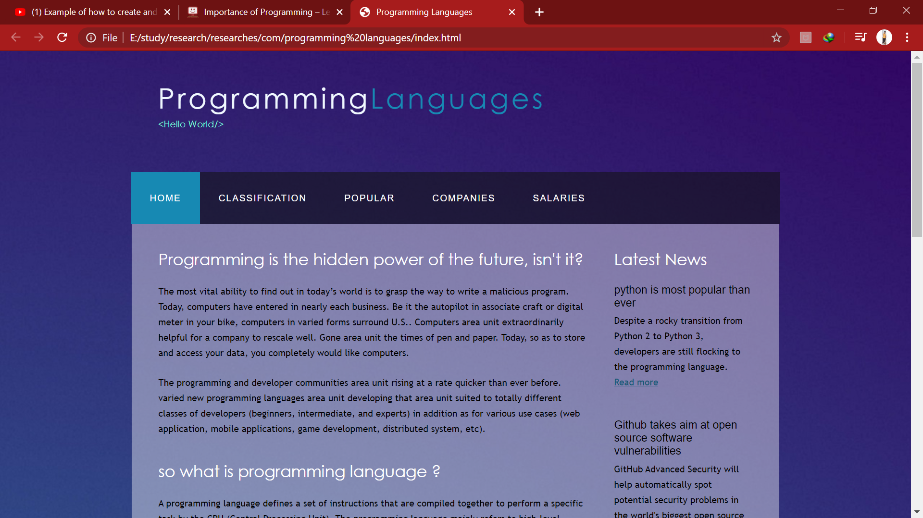Screenshots:

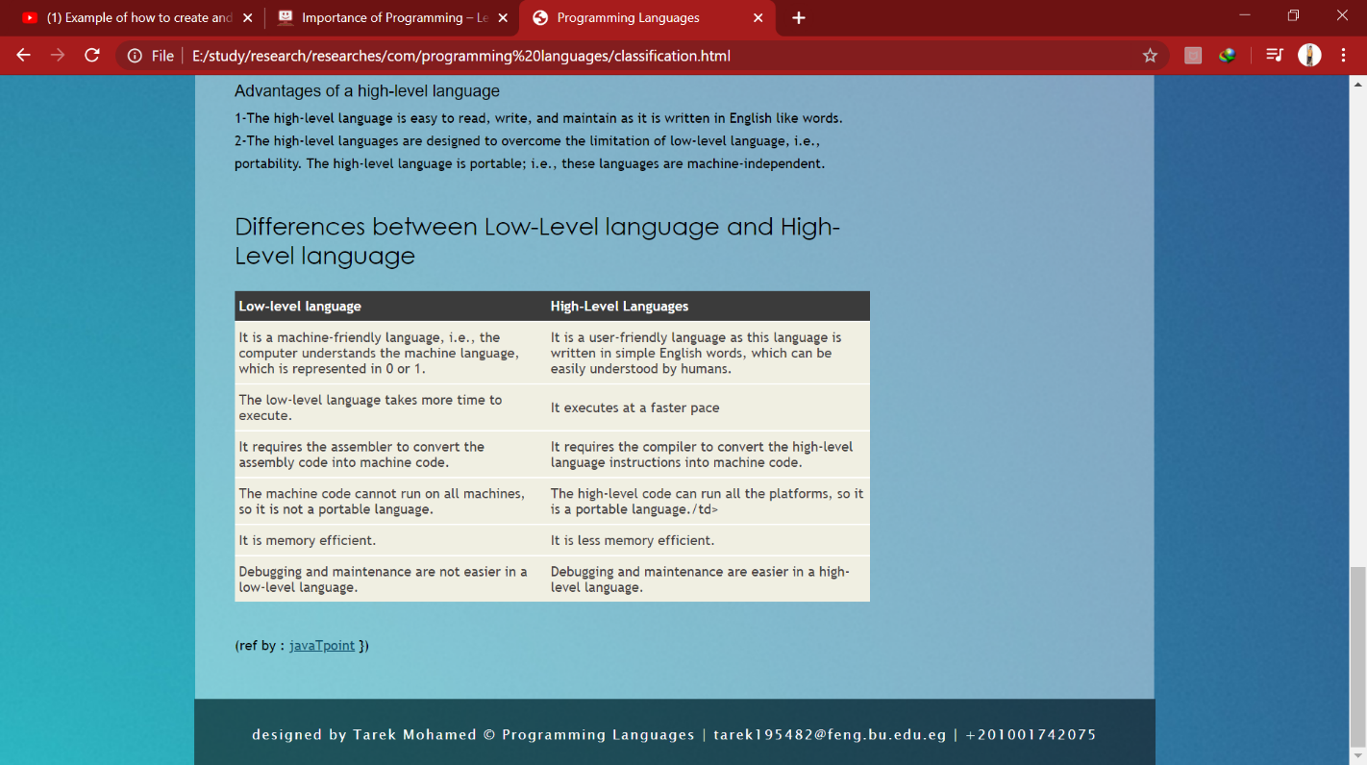

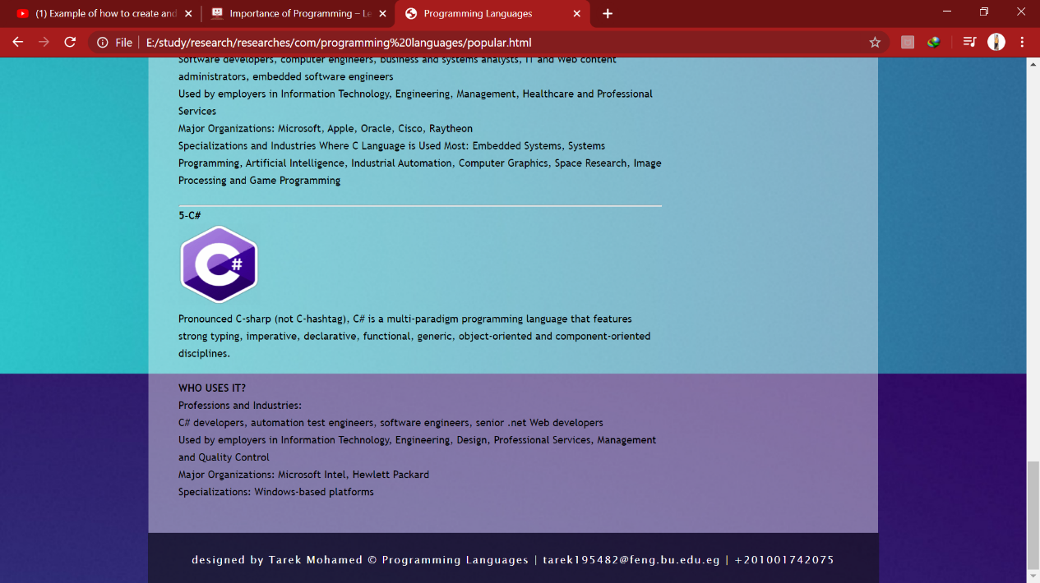

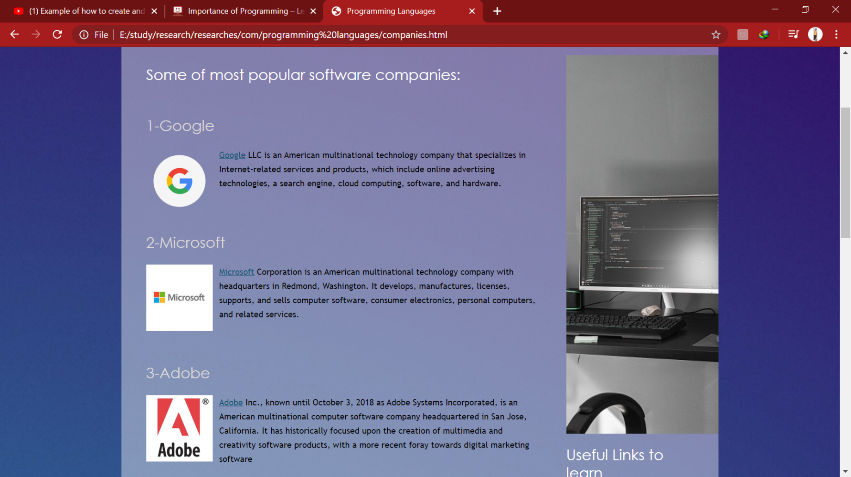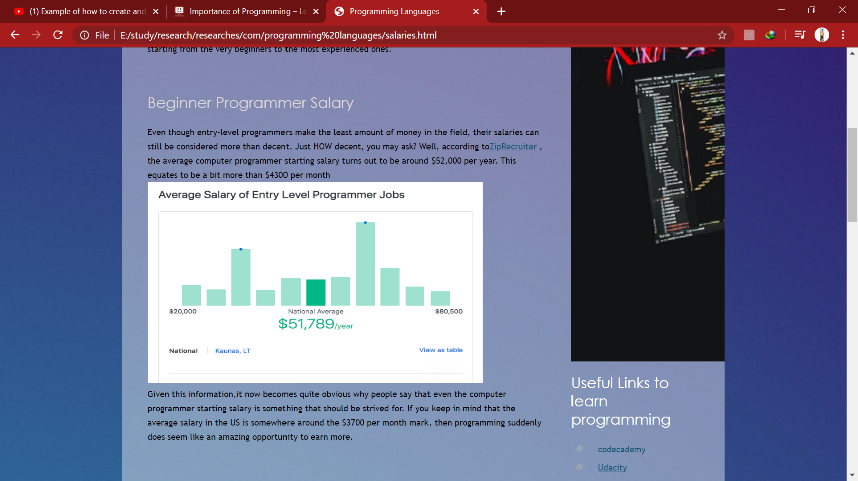

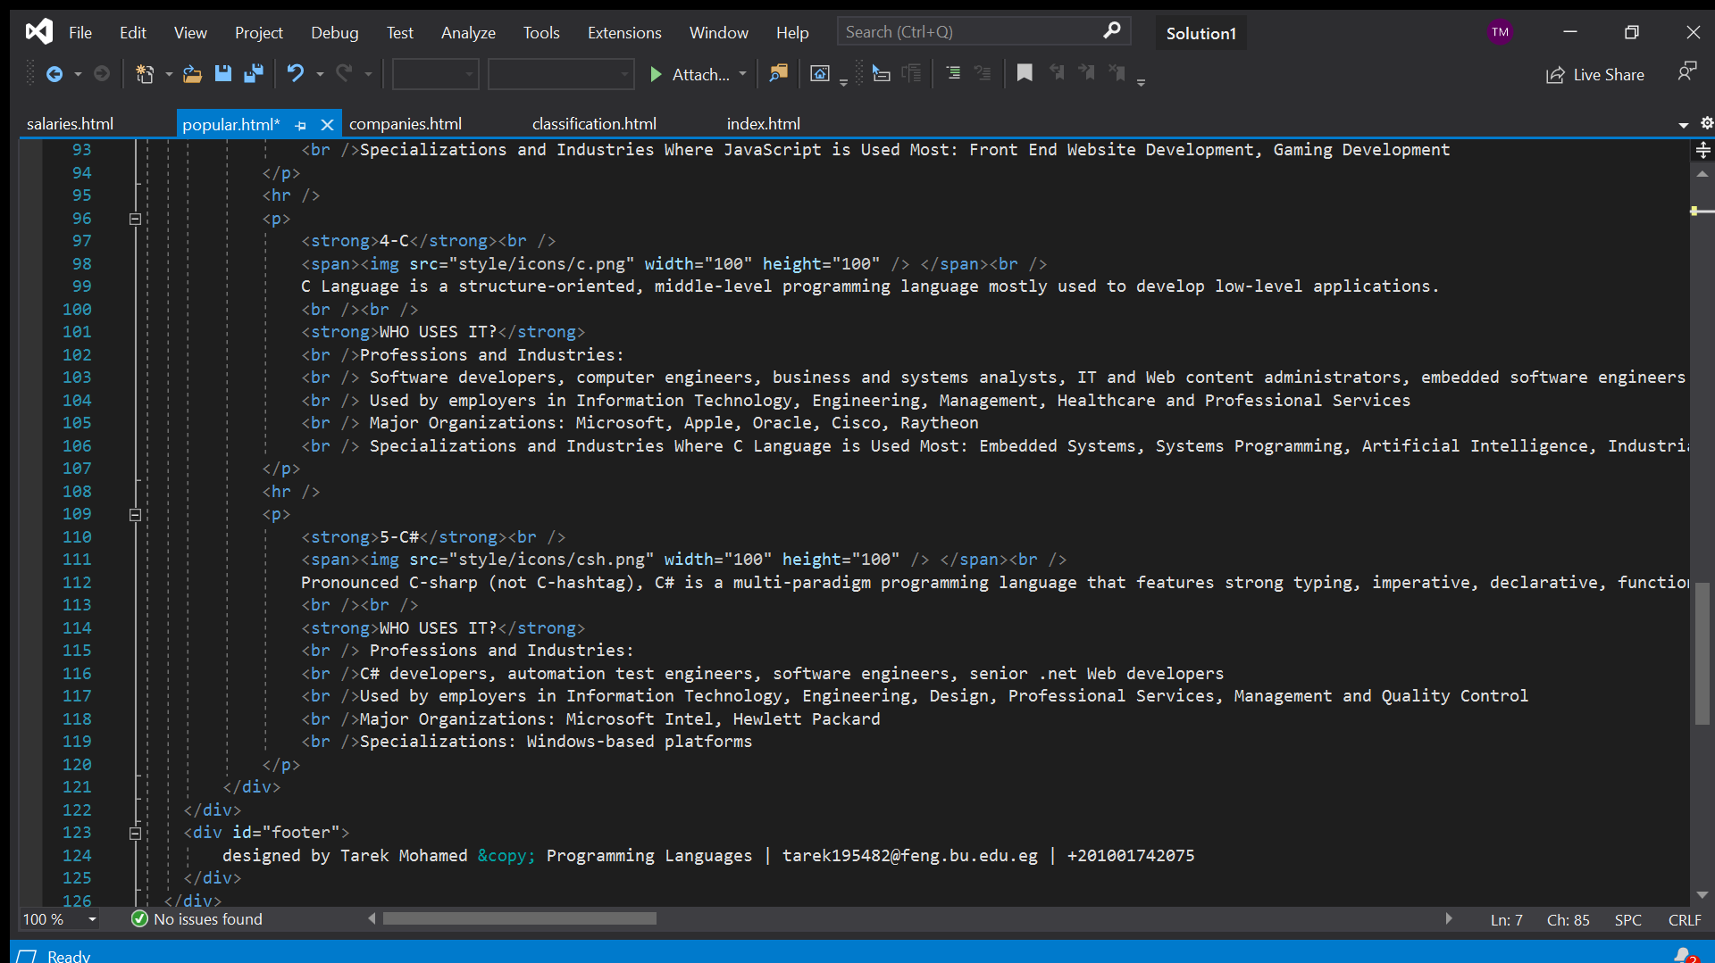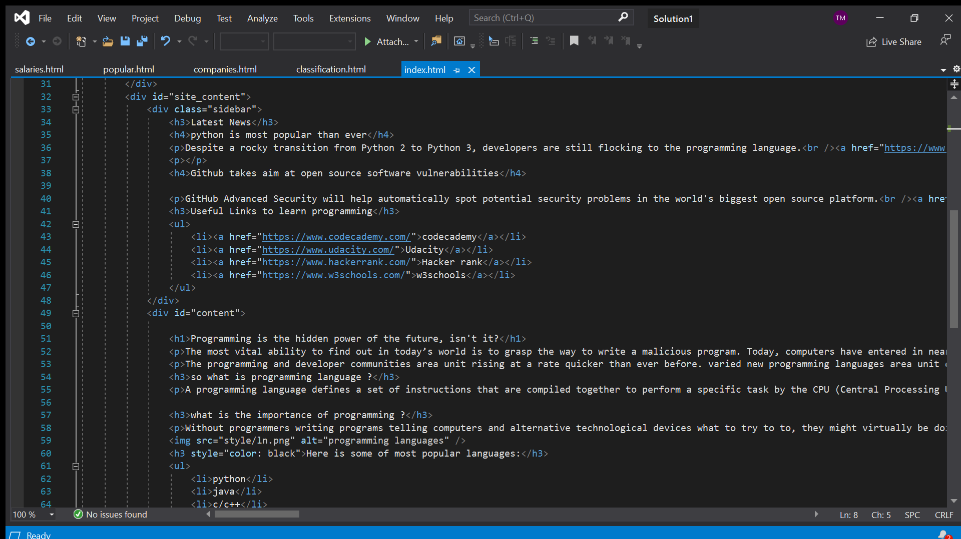Screenshots of Source Code:

